Postal Life Insurance

Department of Post

Software Requirements Specification (SRS)/ Functional Requirements Specification (FRS)
  - Withdrawal of Request

INTERNAL APPROVAL FORM

Project Name: Withdrawal of Request
Version: 1.0
Submitted on:
 | Name | Date
Approved By:
Reviewed By:
Prepared By:

VERSION CONTROL LOG
Version | Date | Prepared By | Remarks
1

Table of Contents

1. Executive Summary 4
2. Project Scope 4
3. Business Requirements 4
4. Functional Requirements Specification 5
4.1 Non-Financial Service Request Indexing page (At Post Office) 5
5. Attachments 6

1. Executive Summary
The purpose of this document is to define the functional and non-functional requirements for the Withdrawal of Service Request (SR) module in the India Post PLI Insurance Management System (IMS). This module will enable customers to withdraw service requests digitally, replacing the current manual process in the McCamish system with an automated, transparent, and customer-centric workflow.

2. Project Scope
The module applies to all PLI customers who wish to withdraw any service request before its completion, including:
- Change of address or nomination.
- Policy loan request.
- Policy revival.
- Surrender or maturity claim (pre-processing).
- Policy servicing amendments.
- Channels supported:
  - Online Portal.
  - Mobile App.
  - Post Office counters.
  - Call Centre / Assisted Digital.

3. Business Requirements

ID | Requirements
FS_WSR_001 | System shall allow customers to initiate withdrawal requests via portal, app, Post Office, or call center.
FS_WSR_002 | System shall validate eligibility based on SR status and withdrawal window.
FS_WSR_003 | System shall auto-approve eligible withdrawals; route exceptions to CPC User.
FS_WSR_004 | System shall update SR status to “Withdrawn by Customer” and archive the request.
FS_WSR_005 | System shall notify customers in real-time via SMS, email, and app.
FS_WSR_006 | System shall maintain a complete audit trail of withdrawal actions.

4. Functional Requirements Specification
Flow Diagram for Withdrawal of Request Process: 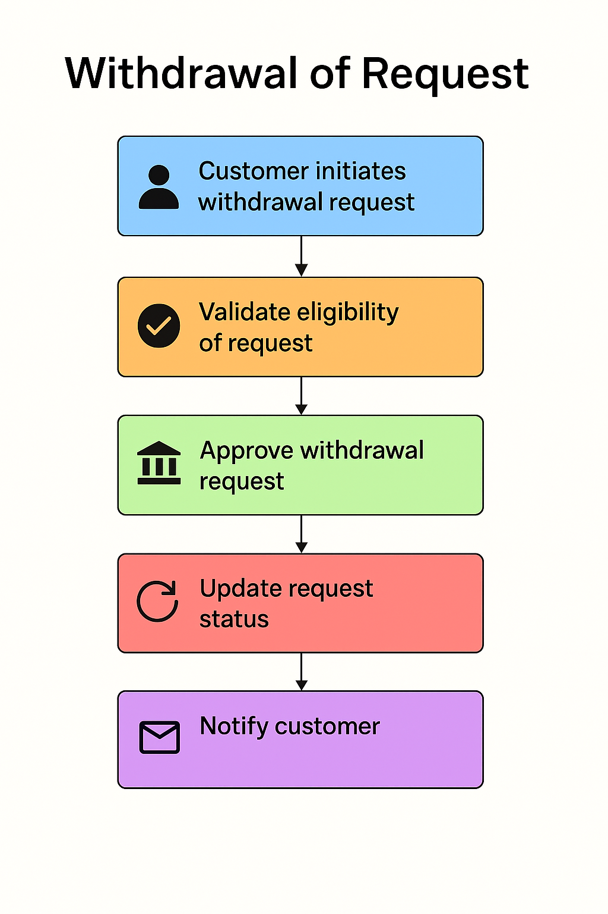

4.1 Non-Financial Service Request Indexing page (At Post Office)
- Purpose: To create Non-Financial Service Request for Withdrawal of Request to drop the service request already created in the IMS System.
- Fields:
  - Request Type: Service request type like Withdrawal of Request, Revival, Surrender, Loan etc.
  - Service Request ID: Service request which needs to be withdrawn.
  - Service Request Date: Date on which service request is indexed.
  - Policy Number: Text
  - Office Code: Facility ID of the office where request is getting indexed
  - Service Request Channel: Channel for the service request like RICT, CP etc.
  - Username: Emp ID of the user indexing the request
- Rules:
  - CPC User should be able to Approve or Reject the request. Upon, Approval, the original service request should be reversed automatically.
  - All the transactions associated with that service request should also be reversed automatically.
  - This transaction will not be applicable if any payment is done by customer or if any disbursement happens from the policy.

5. Attachments
The following documents can be referred.

